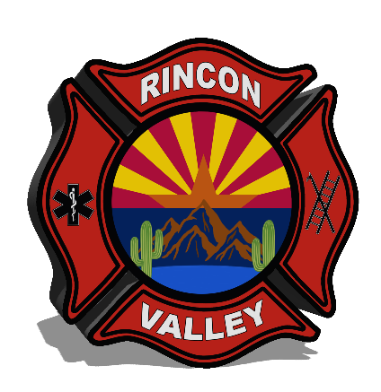
RINCON VALLEY FIRE DISTRICT

Bus. (520) 647-3760 14550 E. Sands Ranch Road Emergency Telephone
Fax. (520) 647-7102 VAIL, AZ. 85641 911

REGULAR MEETING AGENDA
Thursday, October 17, 2024
06:00 PM

The Rincon Valley Fire District Governing Board will meet in Public Session for a Regular Meeting on Thursday, October 17, 2024, at 06:00 PM. Location: Station 292, 14550 E Sands Ranch Rd. Vail, AZ 85641 Community Room.

The following topics will be subject to Governing Board consideration, discussion, approval, or other action. All items on the agenda are set for possible action.

The order of the Agenda may be changed by order of the Board.

- Call to Order/Roll Call

- Pledge of Allegiance

- Date of next meeting: November 21, 2024

- Call to the Public –
Call to the Public. This is the time for public comment to the Governing Board. Speakers are limited to three minutes and may submit written comments of any length to the Governing Board. A person who wishes to address the Governing Board should fill out a Citizen Information Card and hand it to the Clerk or Secretary. Board Members are not required to respond to comments and are prohibited from discussing or taking action on any item raised during the Call to the Public that is not on the agenda. Action taken because of public comment will be limited to directing staff to study the matter, responding to any criticism, or scheduling the matter for further consideration and decision later.

- Employee Recognition – New Hire Badge Pinning Ceremony
- Firefighter Paramedic – Bailey Breeding
- Firefighter Paramedic – Edgar Sawada
- Firefighter EMT – Kieran Anderson

- 2025-016 - Review, discussion, and possible action of the Consent Agenda.
The Consent Agenda contains items that might require action by the Board but are generally routine and do not require discussion. Usually, a single motion will approve all items on the Consent Agenda, including resolutions. However, a Board Member may remove any item from the Consent Agenda, which will be discussed and voted upon separately.

- Approval of the Minutes from the September 19, 2024 Board Meeting.
- Resolution #25-009 – Jiha Annexation – 1121 N Darlene Dr.
- Resolution #25-010 – Loshbough Annexation – 3141 E Wetstones Rd.
- Resolution #25-011 – Agnew Annexation – 203 N Slate Dr.
- Resolution #25-012 – Van Horn/Coronado Annexation – 1141 N Darlene Dr.
- Resolution #25-013 – Jeffery S. Compton Annexation – 10030 S Big Thunder Dr.
- Resolution #25-014 – Sanchez Annexation – 531 N Slate Dr.

- Reports and Correspondence

  - Board Member Report
This is a summary of the Fire Board of Directors' activities regarding the District, which is for review and discussion.

  - 2025-017 - Review and discussion of the Fire Chief Report.

This is a summary of the fire chief and administrative staff's activities in each district division, including fire/rescue operations, administrative services, and support services, for review and discussion.

  - 2025-018—Review, discussion, and possible action on the District’s Financial Report for September 2024.

    - Monthly Board Financial Report, Revenue and Expenditure Reports, Real Estate Tax Revenue, Monthly Bond Report, and Monthly Capital Fund Reports.
    - The Board will be asked to approve the District’s Monthly Disbursements Report.
    - The Board will be asked to approve the Monthly Bank Statements and Reconciliations.

- Unfinished Business

  - 2024-068b - Review, discussion, and possible action regarding appointing a new Board Member to fill a vacancy.

- New Business

  - 2025-019 - Review, discussion, and possible action to approve RVFD Policy Revisions.

- ADJOURNMENT

The Rincon Valley Fire District Board may vote to go into Executive Session on any agenda item according to ARS §38-431.03 (A) (3) for discussion and consultation for legal advice with the Fire District Attorney on the matter(s) as outlined in the agenda item.
Under Board Policy, from time to time, it might be necessary for a Board Member to attend a Board meeting via speakerphone. The Rincon Valley Fire District is accessible to persons with disabilities. In compliance with the Americans with Disabilities Act (ADA), those persons with special needs, such as large-type face print or other reasonable accommodations, may request those through the Rincon Valley Fire District by calling 520-647-3760 before the meeting.

Posted October 14, 2024

